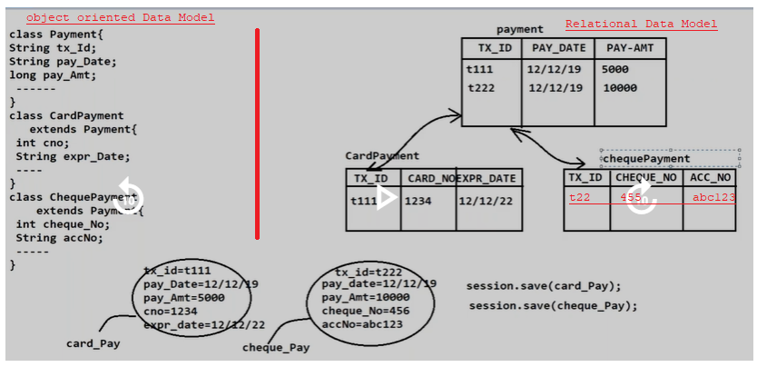

**1.Mapping Object oriented elements with Relational Data Model element using xml tags:**

a.<joined-subclass >:-It is child tag to <class> tag.

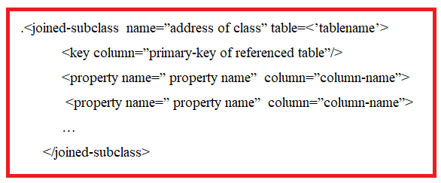

**2.Mapping Object oriented elements with Relational Data Model element using Annotations:**

[a.@Inheritance(Strategy=InheitanceType.joined)](mailto:a.@Inheritance(Strategy=InheitanceType.joined))

It is written just above the parent class.

[b.@PrimaryKeyJoinColumn(name](mailto:b.@PrimaryKeyJoinColumn(name)=” “)

It is written just above the subclass.

Example: Using XML tags.

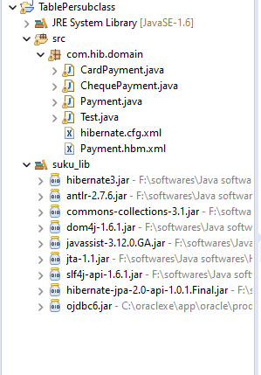

**Domain classes:-**

**1.payment.java**

**package** com.hib.domain;

**import** java.io.Serializable;

**public** **class** Payment **implements** Serializable{

**private** **int** tx_id;

**private** **float** pay_amt;

**private** String pay_Date;

**public** **int** getTx_id() {

**return** tx_id;

}

**public** **void** setTx_id(**int** tx_id) {

**this**.tx_id = tx_id;

}

**public** **float** getPay_amt() {

**return** pay_amt;

}

**public** **void** setPay_amt(**float** pay_amt) {

**this**.pay_amt = pay_amt;

}

**public** String getPay_Date() {

**return** pay_Date;

}

**public** **void** setPay_Date(String pay_Date) {

**this**.pay_Date = pay_Date;

}

}

**2.CardPayment.java**

**package** com.hib.domain;

**public** **class** CardPayment **extends** Payment{

**private** **int** cNo;

**private** String expDate;

**public** **int** getcNo() {

**return** cNo;

}

**public** **void** setcNo(**int** cNo) {

**this**.cNo = cNo;

}

**public** String getExpDate() {

**return** expDate;

}

**public** **void** setExpDate(String expDate) {

**this**.expDate = expDate;

}

}

**3.ChequePayment.java**

**package** com.hib.domain;

**public** **class** ChequePayment **extends** Payment {

**private** **int** cNo;

**private** String accNo;

**public** **int** getcNo() {

**return** cNo;

}

**public** **void** setcNo(**int** cNo) {

**this**.cNo = cNo;

}

**public** String getAccNo() {

**return** accNo;

}

**public** **void** setAccNo(String accNo) {

**this**.accNo = accNo;

}

}

**Hibernate Configuration File:hibernate.cfg.xml**

<?xml version=*"1.0"* encoding=*"UTF-8"*?>

<!DOCTYPE hibernate-configuration PUBLIC

"-//Hibernate/Hibernate Configuration DTD 3.0//EN"

"http://www.hibernate.org/dtd/hibernate-configuration-3.0.dtd">

<hibernate-configuration>

<session-factory>

<property name=*"hibernate.connection.driver_class"*>oracle.jdbc.OracleDriver</property>

<property name=*"hibernate.connection.url"*>jdbc:oracle:thin:@localhost:1521:xe</property>

<property name=*"hibernate.connection.username"*>system</property>

<property name=*"hibernate.connection.password"*>tiger</property>

<property name=*"hibernate.dialect"*>org.hibernate.dialect.OracleDialect</property>

<mapping resource=*"com/hib/domain/Payment.hbm.xml"*/>

</session-factory>

</hibernate-configuration>

**Hibernate MappingFile:Payment.hbm.xml**

<?xml version=*"1.0"* encoding=*"UTF-8"*?>

<!DOCTYPE hibernate-mapping PUBLIC

"-//Hibernate/Hibernate Mapping DTD 3.0//EN"

"http://www.hibernate.org/dtd/hibernate-mapping-3.0.dtd">

<hibernate-mapping>

<class name=*"com.hib.domain.Payment"* table=*"payment"*>

<id name=*"tx_id"* column=*"txid"*/>

<property name=*"pay_amt"* column=*"payamt"*/>

<property name=*"pay_Date"* column=*"paydate"*/>

<joined-subclass name=*"com.hib.domain.CardPayment"* table=*"cardpayment"*>

<key column=*"txid"*/>

<property name=*"cNo"* column=*"cno"*/>

<property name=*"expDate"* column=*"expdate"*/>

</joined-subclass>

<joined-subclass name=*"com.hib.domain.ChequePayment"* table=*"chequepayment"*>

<key column=*"txid"*/>

<property name=*"cNo"* column=*"cno"*/>

<property name=*"accNo"* />

</joined-subclass>

</class>

</hibernate-mapping>

**ClientApplication:Test.java**

**package** com.hib.domain;

**import** org.hibernate.Session;

**import** org.hibernate.SessionFactory;

**import** org.hibernate.Transaction;

**import** org.hibernate.cfg.Configuration;

**public** **class** Test {

**public** **static** **void** main(String[] args) {

Configuration cfg=**new** Configuration();

cfg.configure("com/hib/domain/hibernate.cfg.xml");

SessionFactory sf=cfg.buildSessionFactory();

Session s=sf.openSession();

Payment p=**new** Payment();

CardPayment cp=**new** CardPayment();

ChequePayment cp1=**new** ChequePayment();

Transaction t=s.beginTransaction();

cp.setTx_id(1);

cp.setPay_amt(7000);

cp.setPay_Date("26-07-2023");

cp.setcNo(77);

cp.setExpDate("26-07-2024");

cp1.setTx_id(2);

cp1.setPay_amt(9000);

cp1.setPay_Date("26-07-2023");

cp1.setcNo(78);

cp1.setAccNo("12");

**int** b=(Integer)s.save(cp);

**int** c=(Integer)s.save(cp1);

**if**(b==1&&c==2) {

t.commit();

System.***out***.println("Record Inserted");

}

**else** {

System.***out***.println("Record not inserted");

}

}

}

**Output:**

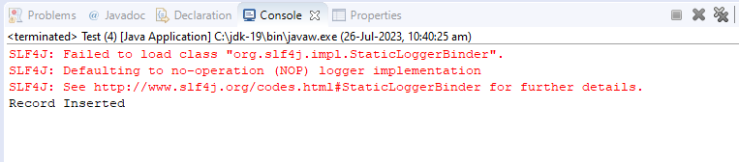

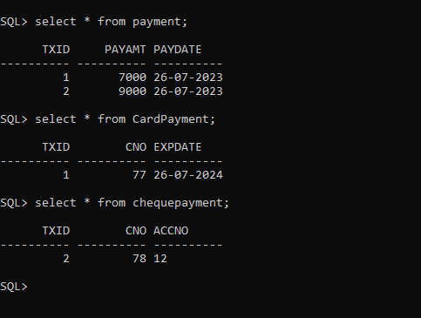

Example:- Using Annatations.

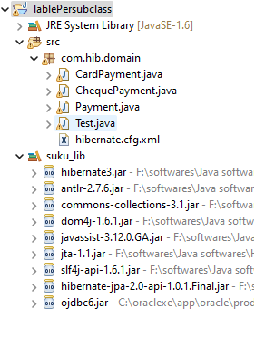

**Domain classes/Annotated classes:**

**1.Payment.java**

**package** com.hib.domain;

**import** java.io.Serializable;

**import** javax.persistence.Column;

**import** javax.persistence.Entity;

**import** javax.persistence.Id;

**import** javax.persistence.Inheritance;

**import** javax.persistence.InheritanceType;

**import** javax.persistence.Table;

@Entity

@Table(name="payment")

@Inheritance(strategy=InheritanceType.***JOINED***)

**public** **class** Payment **implements** Serializable{

@Id

@Column(name="txid")

**private** **int** tx_id;

@Column(name="payamt")

**private** **float** pay_amt;

@Column(name="paydate")

**private** String pay_Date;

**public** **int** getTx_id() {

**return** tx_id;

}

**public** **void** setTx_id(**int** tx_id) {

**this**.tx_id = tx_id;

}

**public** **float** getPay_amt() {

**return** pay_amt;

}

**public** **void** setPay_amt(**float** pay_amt) {

**this**.pay_amt = pay_amt;

}

**public** String getPay_Date() {

**return** pay_Date;

}

**public** **void** setPay_Date(String pay_Date) {

**this**.pay_Date = pay_Date;

}

}

**2.CardPayment.java**

**package** com.hib.domain;

**import** javax.persistence.Column;

**import** javax.persistence.Entity;

**import** javax.persistence.PrimaryKeyJoinColumn;

**import** javax.persistence.Table;

@Entity

@Table(name="cardpayment")

@PrimaryKeyJoinColumn(name="txid")

**public** **class** CardPayment **extends** Payment{

@Column(name="cno")

**private** **int** cNo;

@Column(name="expDate")

**private** String expDate;

**public** **int** getcNo() {

**return** cNo;

}

**public** **void** setcNo(**int** cNo) {

**this**.cNo = cNo;

}

**public** String getExpDate() {

**return** expDate;

}

**public** **void** setExpDate(String expDate) {

**this**.expDate = expDate;

}

}

**3.ChequePayment.java**

**package** com.hib.domain;

**import** javax.persistence.Column;

**import** javax.persistence.Entity;

**import** javax.persistence.PrimaryKeyJoinColumn;

**import** javax.persistence.Table;

@Entity

@Table(name="chequepayment")

@PrimaryKeyJoinColumn(name="txid")

**public** **class** ChequePayment **extends** Payment {

@Column(name="cno")

**private** **int** cNo;

@Column(name="accNo")

**private** String accNo;

**public** **int** getcNo() {

**return** cNo;

}

**public** **void** setcNo(**int** cNo) {

**this**.cNo = cNo;

}

**public** String getAccNo() {

**return** accNo;

}

**public** **void** setAccNo(String accNo) {

**this**.accNo = accNo;

}

}

**HibernateConfigurationfile:hibernate.cfg.xml**

<?xml version=*"1.0"* encoding=*"UTF-8"*?>

<!DOCTYPE hibernate-configuration PUBLIC

"-//Hibernate/Hibernate Configuration DTD 3.0//EN"

"http://www.hibernate.org/dtd/hibernate-configuration-3.0.dtd">

<hibernate-configuration>

<session-factory>

<property name=*"hibernate.connection.driver_class"*>oracle.jdbc.OracleDriver</property>

<property name=*"hibernate.connection.url"*>jdbc:oracle:thin:@localhost:1521:xe</property>

<property name=*"hibernate.connection.username"*>system</property>

<property name=*"hibernate.connection.password"*>tiger</property>

<property name=*"hibernate.dialect"*>org.hibernate.dialect.OracleDialect</property>

**<mapping class=*"com.hib.domain.Payment"*/>**

**<mapping class=*"com.hib.domain.CardPayment"*/>**

**<mapping class=*"com.hib.domain.ChequePayment"*/>**

</session-factory>

</hibernate-configuration>

**ClientApplication:Test.java**

**package** com.hib.domain;

**import** org.hibernate.Session;

**import** org.hibernate.SessionFactory;

**import** org.hibernate.Transaction;

**import** org.hibernate.cfg.Configuration;

**public** **class** Test {

**public** **static** **void** main(String[] args) {

Configuration cfg=**new** Configuration();

cfg.configure("com/hib/domain/hibernate.cfg.xml");

SessionFactory sf=cfg.buildSessionFactory();

Session s=sf.openSession();

Payment p=**new** Payment();

CardPayment cp=**new** CardPayment();

ChequePayment cp1=**new** ChequePayment();

Transaction t=s.beginTransaction();

cp.setTx_id(1);

cp.setPay_amt(7000);

cp.setPay_Date("26-07-2023");

cp.setcNo(77);

cp.setExpDate("26-07-2024");

cp1.setTx_id(2);

cp1.setPay_amt(9000);

cp1.setPay_Date("26-07-2023");

cp1.setcNo(78);

cp1.setAccNo("12");

**int** b=(Integer)s.save(cp);

**int** c=(Integer)s.save(cp1);

**if**(b==1&&c==2) {

t.commit();

System.***out***.println("Record Inserted");

}

**else** {

System.***out***.println("Record not inserted");

}

}

}

**Output;**

